Guillaume GROSJEAN, MD
Hip and Knee Surgeon
Date of birth : Jun. 13 1974
Paris France
French nationality
Marital Status : Married, 2 childs

Business Address :
American Hospital of Paris
Hip and Knee Center
63 Boulevard Victor Hugo 92200 Neuilly sur Seine

Cell number : + 33 6 09 53 78 03

E-mail : docteur.grosjean@gmail.com

Web: www.prothesedugenou.com

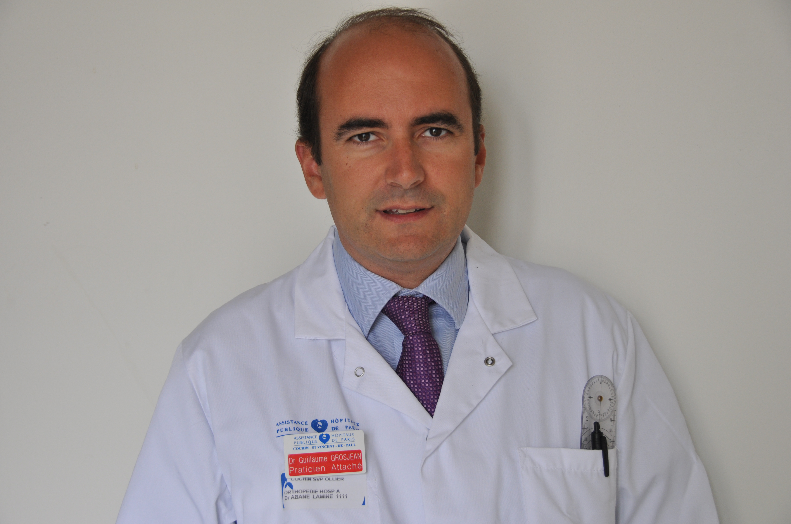

Education

Bac serie C 1993
Medical school Paris Ouest, Paris 1993-2000
Internship 2000

POSITIONS

2000-2005 Resident in Orthopaedic Surgery

2005-2008 Chef de Clinique (Department of Orthopaedic and Reconstructive Surgery,
Service A, Centre Hospitalo-Universitaire Cochin- Port Royal, Paris, France).

2008-Présent Praticien Attaché (Department of Orthopaedic and Reconstructive Surgery,
Service A, Centre Hospitalo-Universitaire Cochin- Port Royal, Paris, France).

2008-Présent Institut de la Hanche et du Genou, Référent Surgeon
Clinique Ambroise Paré 27 Boulevard Victor Hugo 92200 Neuilly sur Seine

2015-Présent Réferent Surgeon in Hip and Knee Surgery, Membre Associé
American Hospital of Paris (A.H.P.), 63 Boulevard Victor Hugo 92200 Neuilly sur Seine

American Joint Commission accreditation

MAIN SURGICAL PRACTICE

About 150 primary and Révision Total Hip performed each year Anterior Approach
High experience in difficult primary total hip arthroplasties including congenital hip dislocation, post
acetabular fracture, post hip fusion

Referent in fast track surgery , E.R.A.S. Rapid enhanced rehabilitation after surgery surgery, accelerate recovery programs.

Ambulatory Surgery in Total Hip and Knee Arthroplasties

Over 150 primary and revision total knee arthroplasties performed each year, with high experience in
major deformation and major reconstruction

PROFFESSIONAL SOCIETY MEMBERSHIP

- American Joint Accréditation
- Société Française de Chirurgie Orthopédique (SOFCOT)
- Société Française de la Hanche et du Genou (SFHG)
- Orthopaedic Research Society (ORS)
- American Society of Orthopaedics Surgeons (AAOS)
- American Association of Hip and Knee Surgeons (AAHKS)

INTERNATIONNAL EXPERIENCE

Mars 2018 American Hospital of Dubaï, United Arab Emirates; Ambulatory Experience in Total Hip Arthroplasty with the anterior Approach

Mars 2009 University Hospital Sharjah, United Arab Emirates, ACL Reconstruction, Techniques and Experiences

May 2008, St Mary's Hospital London, United Kingdom ; Trochanteric Approach in Total Hip Arthroplasty

FOREIGN LANGUAGES

French: Mother tongue
English: fluent
German: basic knowledge

PUBLICATIONS

Triclot P., Grosjean G., El Masri F., Courpied J.P., Hamadouche M.: Propsective randomized penetration rate of highly cross-linked polyethylene at a minimum of 4-year follow-up. A blinded evaluation using the Martell method. J Bone Joint Surg Br. 2007 Nov;89(11):1439-45

Grosjean G, Courpied J.P., Moindreau M., Hunou N., Mathieu M., Hamadouche M. : Faut-il systémayiquement changer une pièce fémorale cimentée monobloc lors d’une reprise d’arthroplastie totale de hanche. Rev Chir Orthop Reparatrice Appar Mot. 2008 Nov;94(7):670-7

Grosjean G, Hamadouche M., Triclot P, El Masri F., Coupied J.P.: Prospective Randomized Penetration Rate of Highly-Cross-linked Polyethylene at a Minimum 4-year Follow-up. 74th Annual Meeting of the American Academy of Orthopaedic Surgeons (AAOS), San Diego, CA, USA, Février 2007.

Hamadouche M., Grosjean G., : Moindreau M., Hunou N., Mathieu M, Courpied J.P Surface damage to the femoral head of monobloc cemented stems in vivo. A mean 14.8-year follow-up study. Orthopaedic Research Society (AAOS/ORS),San Francisco, CA, USA, Mars 2008.

Grosjean G, Hamadouche M.
Should monobloc cemented stems systematically be revised during acetabular revision? Poster Presentation Number: P075. 75th Annual Meeting of the American Academy of Orthopaedic Surgeons (AAOS), San Francisco, CA, USA, Mars 2008

Hamadouche M., Grosjean G., Kerboull L., Courpied J.P., Kerboull M.: Charnley-Kerboull
total hip arthroplasty cobining zirconia on polyethylene. A minimum 2-year follow-up
prospective study. Bioceramics in Joint Arthroplasty. G. Willmann , J. Garino (eds).
Georg thieme Verlag. Stuttgart-New York , 2002, pp96-102.

Grosjean G
Toute rupture de tendon doit être traitée
Le Figaro Rubrique Santé, Mars 2012

Grosjean G
"Les tendinopathies"
La Tribune Santé, Juin 2012

Grosjean G
« La prothèse du genou »
Le Figaro rubrique Santé Juin 2013

ORAL PRESENTATIONS

Grosjean G, Roussignol.X, , O.Collange - E.Clavier - F.Dunet - JP.Mure - F.Rabarin - F.Tirveillot -
SYMPOSIUM-Fracture grave de l'anneau pelvien de l'adulte (cotyle exclu) - Management of severe pelvic ring fractures.ann.orthop.Ouest - 2003-35

Grosjean G, Duparc F, Roussignol X, Polle G, Biga N
La prothèse d’épaule inversée Delta III. Bilan de début d’expérience au C.H.U. Considération à propos de 40 cas. SOFCOT Société Française de Chirurgie Orthopédique Paris Novembre 2006

Grosjean G, Hamadouche M., Triclot P, El Masri F., Coupied J.P.: Prospective Randomized Penetration Rate of Highly-Cross-linked Polyethylene at a Minimum 4-year Follow-up. 74th Annual Meeting of the American Academy of Orthopaedic Surgeons (AAOS), San Diego, CA, USA, Février 2007.

Grosjean G, Sailhan F, Mezghani M, Courpied J.P
Efficacité de la rh-BMP-7 /matrice collagène (OP-1) dans la consolidation des pseudarthroses post-fracturaires SOFCOT Société Française de Chirurgie Orthopédique Paris Novembre 2007.

Grosjean G.: Should monobloc cemenyed stems systematically be revised during revisin THA. A prospective evaluation.
Annual Meeting of the American Academy of Orthopaedic Surgeons (AAOS), San Francisco, CA, USA 2008.

Grosjean G, Courpied JP Hamadouche M.
Faut-il systémayiquement changer une pièce fémorale cimentée monobloc lors d’une reprise d’arthroplastie totale de hanche.
SOFCOT Société Française de Chirurgie Orthopédique Paris Novembre 2008.

Grosjean G.
Modérateur session Hanche
SOFCOT Société Française de Chirurgie Orthopédique Paris Novembre 2012

